**“Open Source Software Laboratory”**

**Code: 4IT475**

Submitted by

**Mr. Adwait Samak (2020BTEIT00021)**

**Email:** adwait.samak@walchandsangli.ac.in

**Mobile:** 7757091299



DEPARTMENT OF INFORMATION TECHNOLOGY

**WALCHAND COLLEGE OF ENGINEERING, SANGLI**

**(An Autonomous Institute)**

**2023-2024**

1. **Use of Open Source tools for Project Management.**

* **(Sonar,** [**Targetprocess**](https://blog.capterra.com/free-open-source-project-management-software/#11)**,** [**Redbooth**](https://blog.capterra.com/free-open-source-project-management-software/#10)**,** [**Pivotal Tracker**](https://blog.capterra.com/free-open-source-project-management-software/#9)**, OrangeScrum, etc.: Any One)**

**(Submission by Individual [I])**

***Objective:*** *To install and demonstrate the use of various open source software that is used in day to day life of software Engg.*

***Outcome:*** *(PO: k, l)*

Students have to experiment with the last two project management tools/software and they have to use them for their project/FOSS project/mini project.

In the journal, they have to write information about that tool such as:-

1. The purpose behind that tool.
2. Various versions of those tools.
3. Installation and Configuration of that tool.
4. How to use that tool.

Reference:-

1. <https://bitnami.com/stacks>
2. Sphinx for all lab/college documentation by the students.
3. http://www.sonarqube.org/
4. Wikipedia List Of Software:- [http://en.wikipedia.org/wiki/List_of_free_and_open](http://en.wikipedia.org/wiki/List_of_free_and_open-source_software_packages)- [source_software_package](http://en.wikipedia.org/wiki/List_of_free_and_open-source_software_packages)s
5. Open Source Software Mega List:-

<http://www.datamation.com/open-source/open->  [source-software-the-mega-list.htm](http://www.datamation.com/open-source/open-source-software-the-mega-list-1.html)l

1. <https://fedoraproject.org/wiki/Education_Spin> This has lots of relevant packages
2. <http://www.methodsandtools.com/tools/targetprocess.php>
3. <https://blog.capterra.com/free-open-source-project-management-software/>
4. <http://www.targetprocess.com/>
5. <https://www.pivotaltracker.com/features/>
6. https://redbooth.com/features

## **Use of Open Source tools for Project Management.**

**Title-** Use of project management tools for project management.

**Objective:** To install, use and demonstrate the project management tool that is used in day to day life of software engineers.

**About:**

Asana: Empowering Effective Task and Project Management

Asana is a powerful tool for teams seeking efficient task and project management. It streamlines workflows, enhances collaboration, and optimizes productivity, making it a vital asset in overcoming chaos and meeting project deadlines. As a web-based task management and collaboration platform, Asana eliminates the clutter of email communication, consolidating all tasks and interactions within one cohesive space.

**Features of Asana**

Asana offers a plethora of features that contribute to its effectiveness as a task and project management tool:

1. **Multiple Project Views**: Asana provides users with diverse project viewing options, including Kanban boards, lists, calendars, portfolios, workloads, and timelines. This versatility empowers team members to choose the view that best suits their working style. Project managers can gain comprehensive insights into project progress by switching between views and even creating customized real-time project dashboards.

2. **Project Management Automation**: Automation is simplified within Asana, enabling the creation of custom rules, triggers, and actions. Asana's graphical workflow builder facilitates the setup of both simple and complex automation, reducing repetitive tasks and ensuring seamless processes. From assigning tasks to Slack notifications for project completion, automation enhances efficiency.

3. **Team Collaboration**: Asana stands out with its robust collaboration features, acting as a centralized hub for file sharing, team communication, and coordination. Users can assign tasks, establish task dependencies, set priorities, due dates, and engage in discussions within a single card. The calendar view facilitates scheduling coordination, eliminating the need for constant back-and-forth emails. The software integrates with email apps and third-party messaging tools to cater to various communication preferences.

4. **Agile and Scrum Support**: Asana accommodates agile project management methodologies, offering tools for sprint planning, bug tracking, product launches, work requests, roadmaps, feedback, and task iterations. It's adaptable to different project management philosophies, providing a glossary and guides to align with standard Agile terminology.

5. **Versatility**: Asana's adaptability suits various management approaches, business sizes, and industries. It's a versatile solution for marketing, sales, product development, operations, HR, IT, and finance departments. Its flexibility fosters collaboration across different departments and uses cases, making it applicable to diverse scenarios.

6. **Powerful Integrations**: Asana integrates seamlessly with over 100 popular third-party apps, including Slack, Dropbox, Google Drive, Zapier, Tableau, Zoom, and Salesforce. These integrations extend Asana's capabilities, enabling instant notifications, streamlined data sharing, and enhanced functionality. Note that specific advanced integrations may be plan-dependent.

**Screenshots**

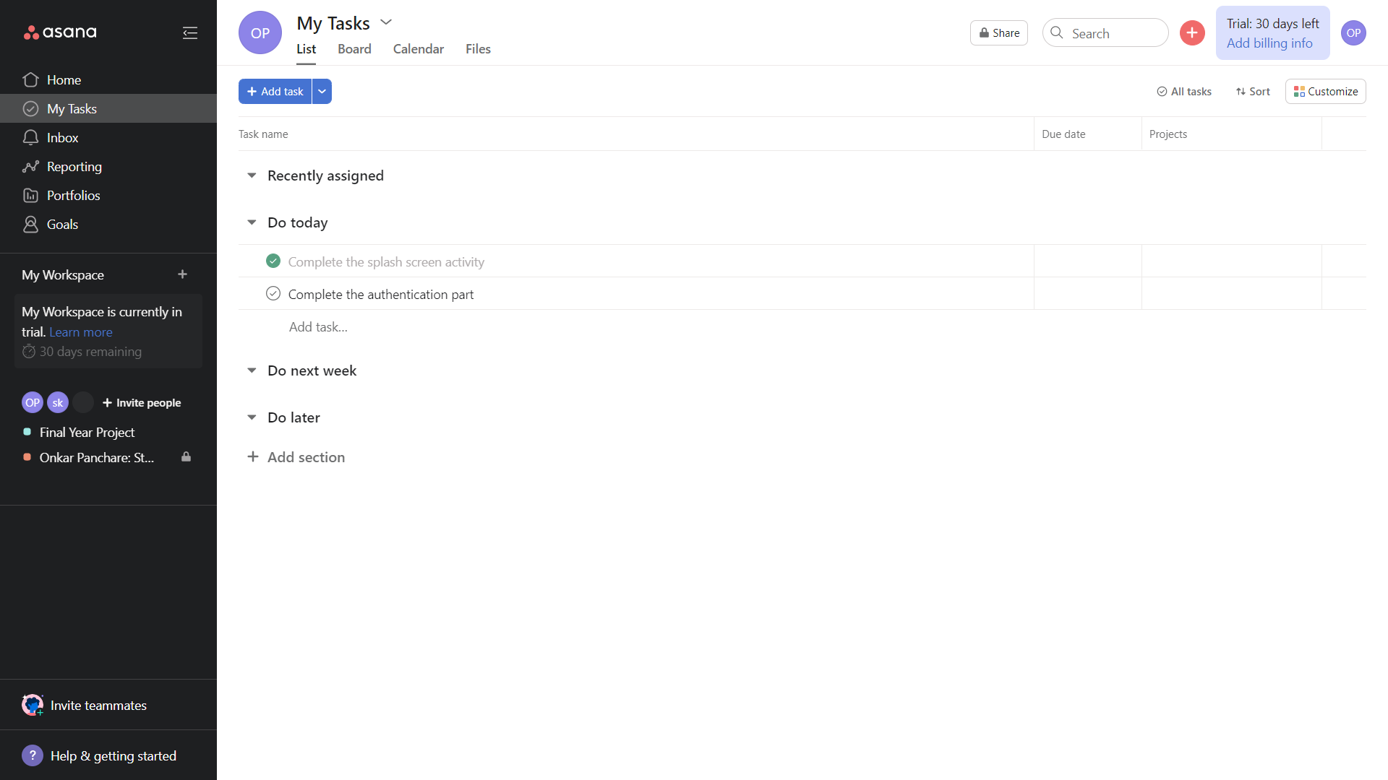

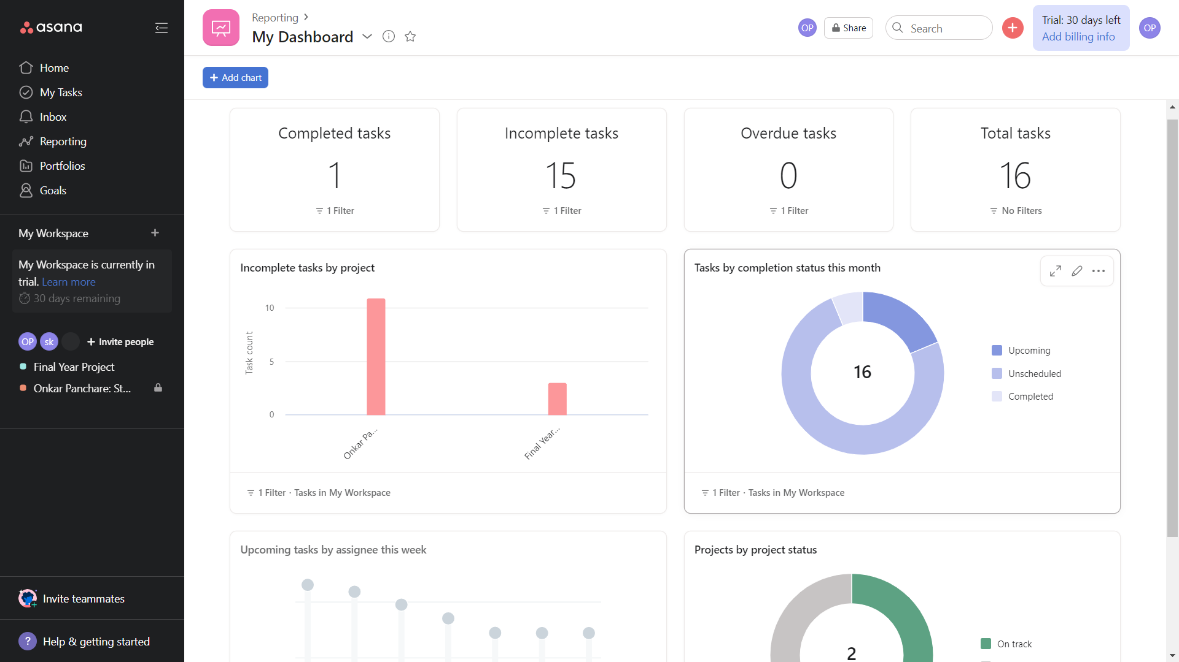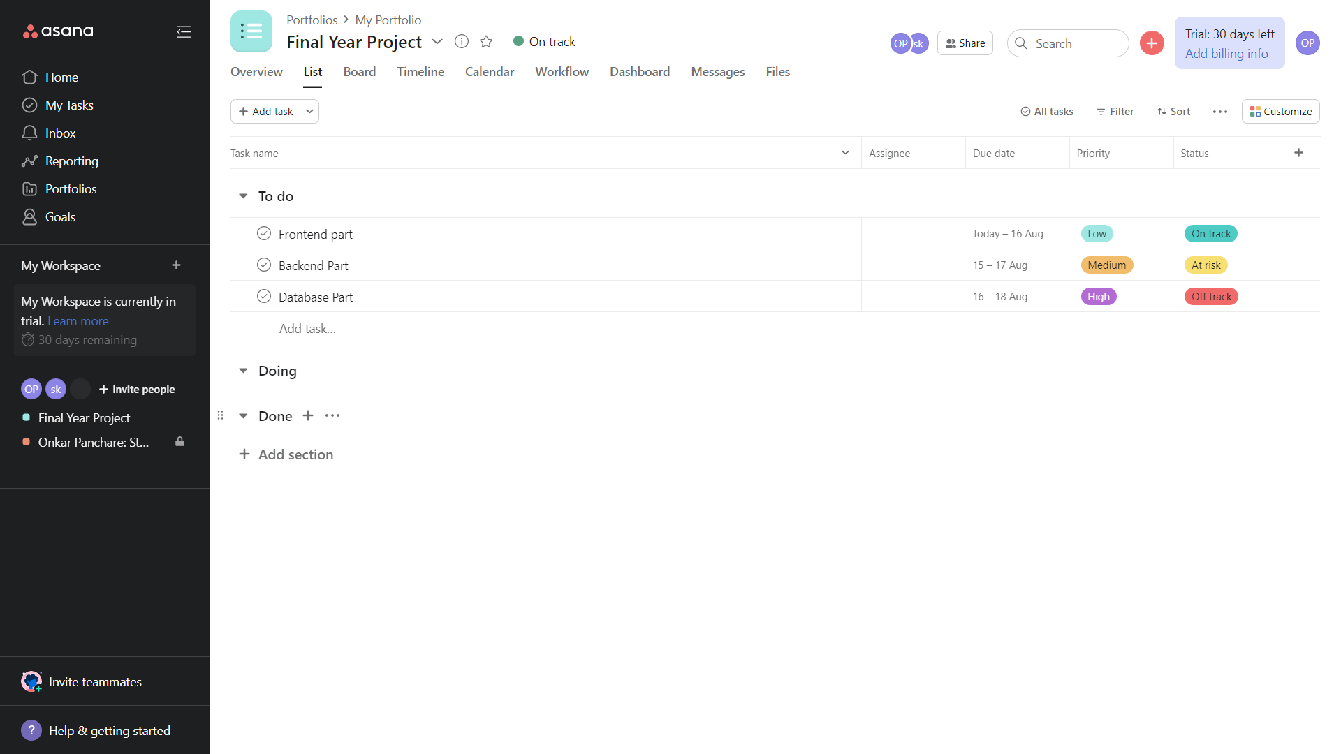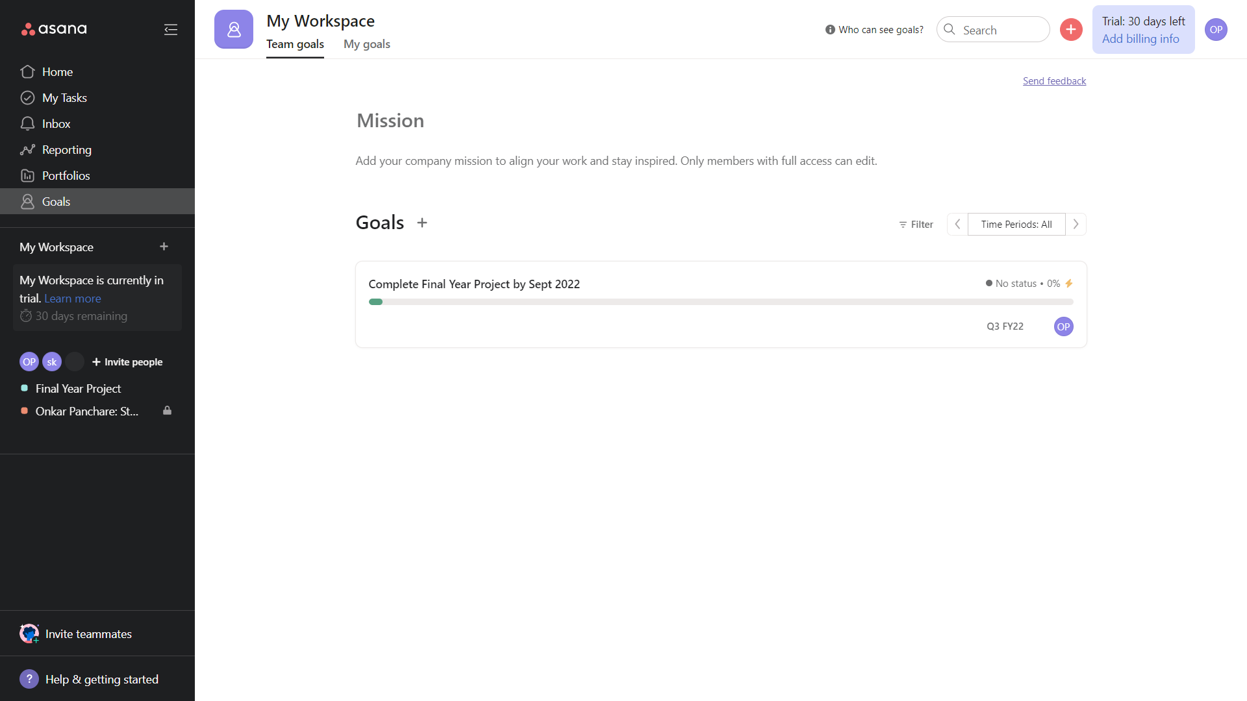

**About:**

Open Atrium: Enhancing Team Collaboration

Open Atrium is a comprehensive suite of tools designed to facilitate effective team collaboration. It leverages the strengths of the Drupal platform to create secure, scalable, and customizable websites that foster enhanced communication and project management within teams. The toolset includes features such as a blog, wiki, calendar, case tracker, shoutbox, and dashboard, which collectively enable the development and management of interactive, responsive, and visually appealing websites.

**Features of Atrium**:

When Open Atrium is installed, it offers six core features by default, contributing to improved team collaboration:

1. Atrium Blog: Facilitates the sharing of stories and information among group members through blog posts.

2. Atrium Notebook: Enables organized documentation creation within groups.

3. Atrium Calendar: Adds a group calendar with the ability to schedule collective events.

4. Atrium Case Tracker: Manages and tracks issues, allowing assignment to members and discussion.

5. Atrium Shoutbox: Offers a quick discussion board for concise discussions and comments.

6. Spaces Dashboard: Provides a configurable dashboard on the group's home page to review new or updated information easily.

**Installation Steps**:

To set up Open Atrium, follow these installation steps:

1. Install the LAMP Stack:

sudo apt-get install lamp-server

sudo /etc/init.d/apache2 start

2. Configure PHP:

sudo gedit /etc/php5/apache2/php.ini

sudo /etc/init.d/apache2 restart

3. Create a Database for Atrium:

SQL

MySQL -u root -p

CREATE DATABASE open atrium;

4. Install Atrium:

sudo mv open atrium-7.x-2.44-core.tar.gz /var/www/html

cd /var/www/html

sudo tar xvf open atrium-7.x-2.44-core.tar.gz

sudo mv open atrium-7.x-2.44 open atrium

sudo chmod -R 777 open atrium

cd sites/default

sudo cp default.settings.php settings.php

5. Complete Installation:

Launch your browser and navigate to http://localhost/openatrium to complete the web-based installation process.

**References**

1. https://blog.hubstaff.com/slack-project-management-2/
2. https://www.simplilearn.com/tutorials/asana-tutorial/what-is-asana-project-management-tool
3. https://www.drupal.org/project/atriumfeatures
4. http://linuxpitstop.com/install-open-atrium-on-ubuntu-linux